

**SCHOOL OF COMPUTER SCIENCE ENGINEERING**

**AND INFORMATION SYSTEMS**

**FALL SEMESTER 2024-2025**

**PMCA503P – DATABASE SYSTEMS LAB**

**CYCLESHEET – PL/SQL**

**SUBMITTED ON: 03 – OCT - 2024**

**SUBMITTED BY-**

**AKASH KUMAR BANIK**

**PROGRAM: MCA**

**REGISTER No.: 24MCA0242**

**CYCLESHEET – PL/SQL**

Consider the following relational database schema for teaching-learning process in a university.

(Source: Database Systems – Coronel & Morris)

PROFESSOR(Prof_id, Prof_name, Email, Mobile, Specialty, Dept_id)

SCHOOL(SCode, Scl_name, Prof_id, Location)

DEPARTMENT(Dept_id, Dname, SCode, Prof_id)

COURSE(Crs_code, Crs_name, Description, Credits, Hours)

CLASS(Cls_code, Slot, Stime, Etime, Crs_code, Prof_id, Room_no, Sem_code, Day_of_week)

SEMESTER(Sem_code, Term, Year, Sdate, Edate)

STUDENT(Reg_no, Sname, Address, DoB, Email, Mobile, Dept_id, Prof_id)

ENROLL(Cls_code, Reg_no, Enroll_time, Grade)

STUDENT_VISA(Reg_no, Visa_status)

PROGRAMME(Prog_code, Prog_name, Prog_preamble, Scode, Dept_id)

The primary keys are underlined and foreign keys are self-explanatory. The Dept_id column in professor table stands for the department the professor belongs to and Prof_id column in the school table stands for the professor who chairs the school, the same column in the department table stands for the professor who heads the department, the domain of Term column in semester table is {Winter, Fall}.

**CYCLESHEET – PL/SQL**

1. Write a PL/SQL block to get the student register number and print the student details such as sname, address, dob, email and mobile number.

**CODE:**

DECLARE

v_reg_no STUDENT_24MCA0242.Reg_no%TYPE;

v_sname STUDENT_24MCA0242.Sname%TYPE;

v_address STUDENT_24MCA0242.Address%TYPE;

v_dob STUDENT_24MCA0242.DoB%TYPE;

v_email STUDENT_24MCA0242.Email%TYPE;

v_mobile STUDENT_24MCA0242.Mobile%TYPE;

BEGIN

v_reg_no := '&Enter_Student_Reg_No';

SELECT Sname, Address, DoB, Email, Mobile

INTO v_sname, v_address, v_dob, v_email, v_mobile

FROM STUDENT_24MCA0242 WHERE Reg_no = v_reg_no;

DBMS_OUTPUT.PUT_LINE('Student Name: ' || v_sname);

DBMS_OUTPUT.PUT_LINE('Address: ' || v_address);

DBMS_OUTPUT.PUT_LINE('Date of Birth: ' || v_dob);

DBMS_OUTPUT.PUT_LINE('Email: ' || v_email);

DBMS_OUTPUT.PUT_LINE('Mobile: ' || v_mobile);

EXCEPTION

WHEN NO_DATA_FOUND THEN

DBMS_OUTPUT.PUT_LINE('No student found with Reg_no: ' || v_reg_no);

WHEN OTHERS THEN

DBMS_OUTPUT.PUT_LINE('Error: ' || SQLERRM);

END;

/

**OUTPUT:**

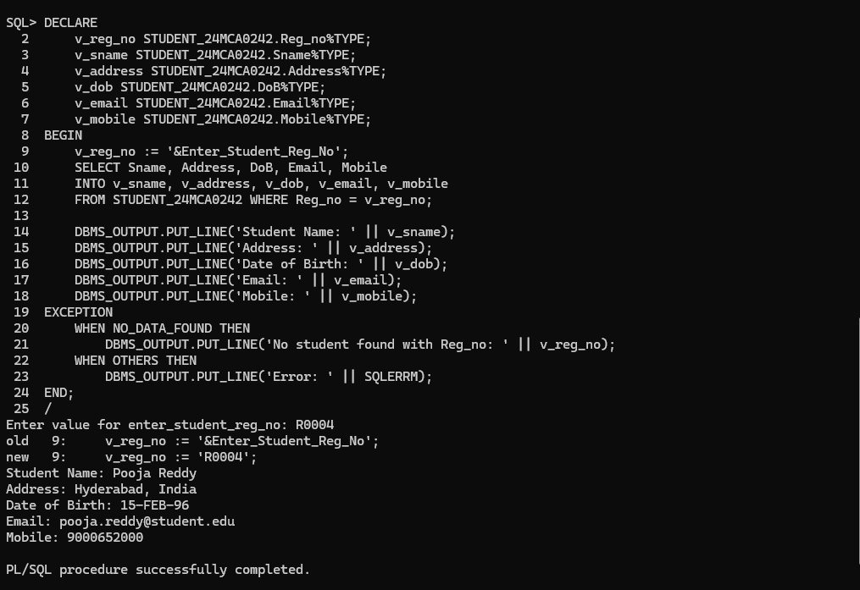

1. Write a PL/SQL block the get the professor id and update the mobile number of the professor.

**CODE:**

DECLARE

v_prof_id PROFESSOR_24MCA0242.Prof_id%TYPE;

v_new_mobile PROFESSOR_24MCA0242.Mobile%TYPE;

BEGIN

v_prof_id := '&Enter_Professor_ID';

v_new_mobile := '&Enter_New_Mobile_Number';

UPDATE PROFESSOR_24MCA0242

SET Mobile = v_new_mobile

WHERE Prof_id = v_prof_id;

IF SQL%ROWCOUNT = 0 THEN

DBMS_OUTPUT.PUT_LINE('No professor found with Prof_id: ' || v_prof_id);

ELSE

DBMS_OUTPUT.PUT_LINE('Mobile number updated successfully for Prof_id: ' || v_prof_id);

END IF;

EXCEPTION

WHEN OTHERS THEN

DBMS_OUTPUT.PUT_LINE('Error: ' || SQLERRM);

END;

/

**OUTPUT:**

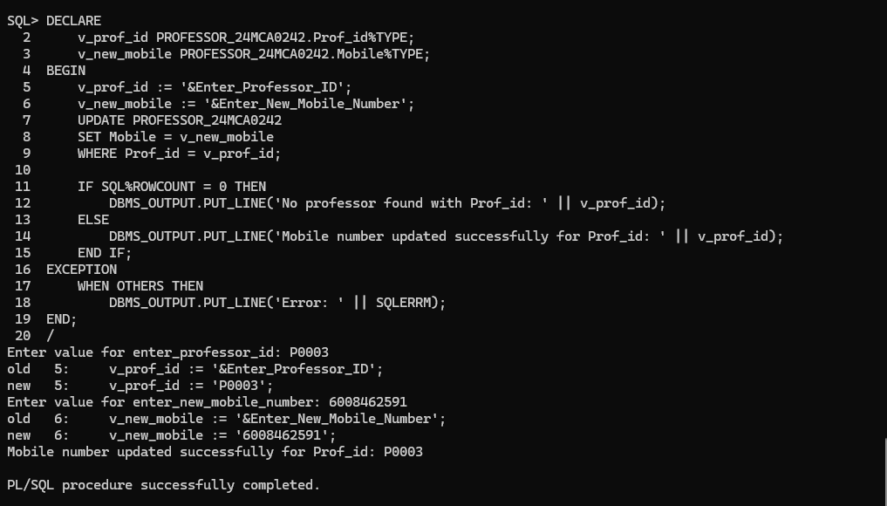

1. Write a PL/SQL procedure to display the message as ‘Excellent’, ‘Good’, and ‘Fair’ depending on the Grade of a student in a course.

**CODE:**

DECLARE

v_grade ENROLL_24MCA0242.Grade%TYPE;

BEGIN

SELECT Grade

INTO v_grade

FROM ENROLL_24MCA0242

WHERE Reg_no = '&Enter_Student_Reg_No'

AND Cls_code = '&Enter_Class_Code';

CASE v_grade

WHEN 'S' THEN

DBMS_OUTPUT.PUT_LINE('Grade is S: Excellent');

WHEN 'A' THEN

DBMS_OUTPUT.PUT_LINE('Grade is A: Very Good');

WHEN 'B' THEN

DBMS_OUTPUT.PUT_LINE('Grade is B: Good');

WHEN 'C' THEN

DBMS_OUTPUT.PUT_LINE('Grade is C: Fair');

WHEN 'D' THEN

DBMS_OUTPUT.PUT_LINE('Grade is D: Needs Improvement');

ELSE

DBMS_OUTPUT.PUT_LINE('Invalid Grade');

END CASE;

END;

/

**OUTPUT:**

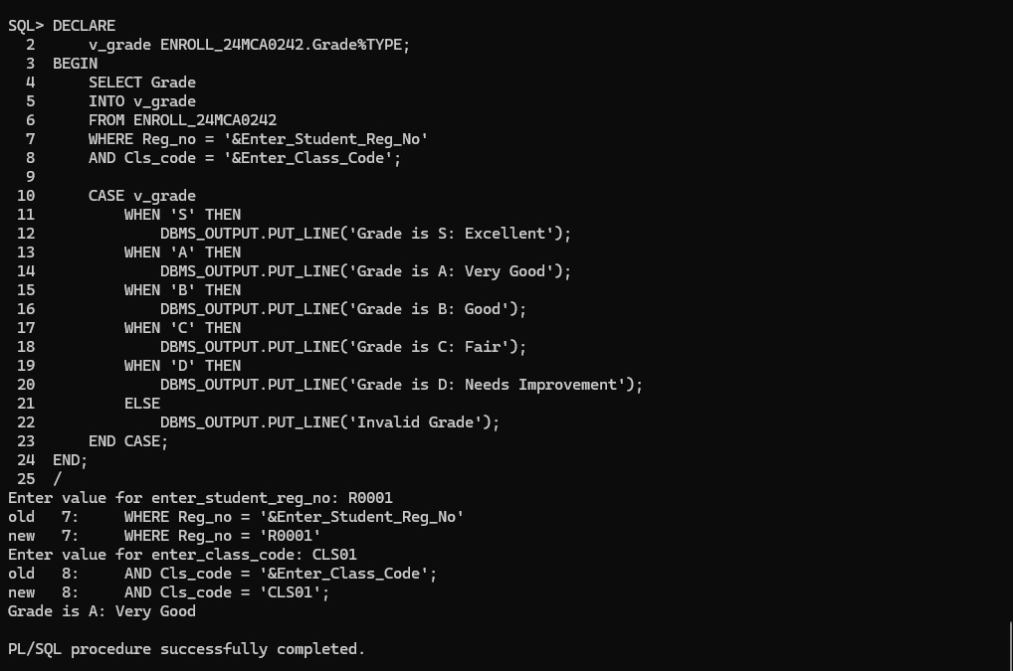

1. Write a PL/SQL procedure to print the number of ‘S’ grades that a student has obtained.

**CODE:**

DECLARE

v_reg_no ENROLL_24MCA0242.Reg_no%TYPE;

v_s_grade_count NUMBER;

BEGIN

v_reg_no := '&Enter_Student_Reg_No';

SELECT COUNT(*)

INTO v_s_grade_count

FROM ENROLL_24MCA0242

WHERE Reg_no = v_reg_no AND Grade = 'S';

DBMS_OUTPUT.PUT_LINE('Number of ''S'' Grades: ' || v_s_grade_count);

EXCEPTION

WHEN NO_DATA_FOUND THEN

DBMS_OUTPUT.PUT_LINE('No grades found for Reg_no: ' || v_reg_no);

WHEN OTHERS THEN

DBMS_OUTPUT.PUT_LINE('Error: ' || SQLERRM);

END;

/

**OUTPUT:**

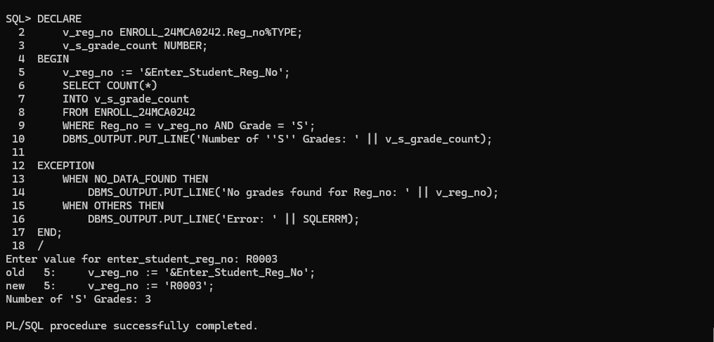

1. Write a PL/SQL program to print the regno and student names who are studying in the first semester.

**CODE:**

DECLARE

CURSOR first_sem_students IS

SELECT s.Reg_no, s.Sname

FROM STUDENT_24MCA0242 s

JOIN ENROLL_24MCA0242 e ON s.Reg_no = e.Reg_no

JOIN CLASS_24MCA0242 c ON e.Cls_code = c.Cls_code

JOIN SEMESTER_24MCA0242 sem ON c.Sem_code = sem.Sem_code

WHERE sem.Sem_code = 'Fall2024-25'

AND sem.Term = 'Fall'

AND sem.Year = 2024;

v_reg_no STUDENT_24MCA0242.Reg_no%TYPE;

v_sname STUDENT_24MCA0242.Sname%TYPE;

BEGIN

OPEN first_sem_students;

DBMS_OUTPUT.PUT_LINE('Students in First Semester:');

LOOP

FETCH first_sem_students INTO v_reg_no, v_sname;

EXIT WHEN first_sem_students%NOTFOUND;

DBMS_OUTPUT.PUT_LINE('Reg_no: ' || v_reg_no || ', Name: ' || v_sname);

END LOOP;

CLOSE first_sem_students;

EXCEPTION

WHEN OTHERS THEN

DBMS_OUTPUT.PUT_LINE('Error: ' || SQLERRM);

END;

/

**OUTPUT:**

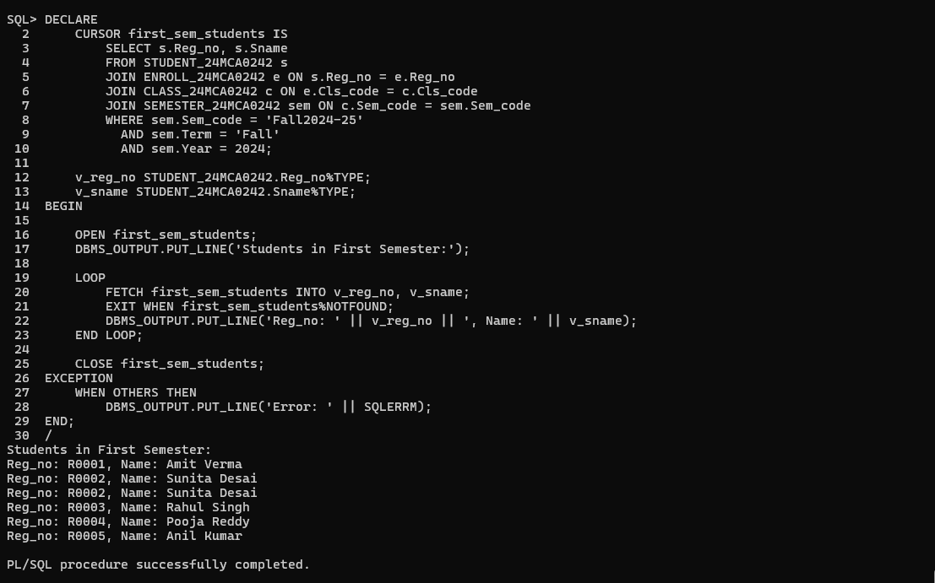

1. Write a PL/SQL program to find out what are all the courses that a professor has handled in the semester 1 and 2.

**CODE:**

DECLARE

v_prof_id PROFESSOR_24MCA0242.Prof_id%TYPE := '&Enter_Prof_id';

BEGIN

DBMS_OUTPUT.PUT_LINE('Courses handled by Professor ' || v_prof_id || ' in First Semester (Fall 2024-25):');

FOR rec IN (

SELECT c.Crs_name

FROM CLASS_24MCA0242 cl

JOIN COURSE_24MCA0242 c ON cl.Crs_code = c.Crs_code

JOIN SEMESTER_24MCA0242 s ON cl.Sem_code = s.Sem_code

WHERE cl.Prof_id = v_prof_id

AND s.Term = 'Fall'

AND s.Year = 2024

) LOOP

DBMS_OUTPUT.PUT_LINE('- ' || rec.Crs_name);

END LOOP;

DBMS_OUTPUT.PUT_LINE('Courses handled by Professor ' || v_prof_id || ' in Second Semester (Winter 2024-25):');

FOR rec IN (

SELECT c.Crs_name

FROM CLASS_24MCA0242 cl

JOIN COURSE_24MCA0242 c ON cl.Crs_code = c.Crs_code

JOIN SEMESTER_24MCA0242 s ON cl.Sem_code = s.Sem_code

WHERE cl.Prof_id = v_prof_id

AND s.Term = 'Winter'

AND s.Year = 2024

) LOOP

DBMS_OUTPUT.PUT_LINE('- ' || rec.Crs_name);

END LOOP;

END;

/

**OUTPUT:**

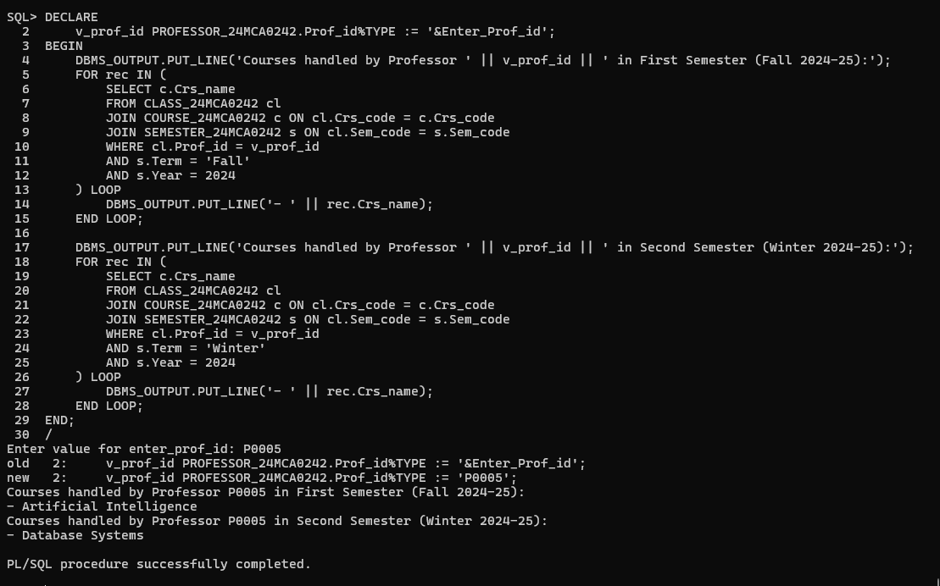

1. Implement and test a trigger to ensure that a student cannot enroll in a course after the semester has started.

**CODE:**

CREATE OR REPLACE TRIGGER check_enroll_date

BEFORE INSERT ON ENROLL_24MCA0242

FOR EACH ROW

DECLARE

v_sdate SEMESTER_24MCA0242.Sdate%TYPE;

BEGIN

SELECT Sem.Sdate

INTO v_sdate

FROM SEMESTER_24MCA0242 Sem

JOIN CLASS_24MCA0242 C ON Sem.Sem_code = C.Sem_code

WHERE C.Cls_code = :NEW.Cls_code;

IF :NEW.Enroll_time > v_sdate THEN

RAISE_APPLICATION_ERROR(-20001, 'Enrollment is not allowed after the semester start date.');

END IF;

EXCEPTION

WHEN NO_DATA_FOUND THEN

RAISE_APPLICATION_ERROR(-20002, 'Invalid class or semester.');

WHEN OTHERS THEN

RAISE_APPLICATION_ERROR(-20003, 'Error: ' || SQLERRM);

END;

/

**OUTPUT:**

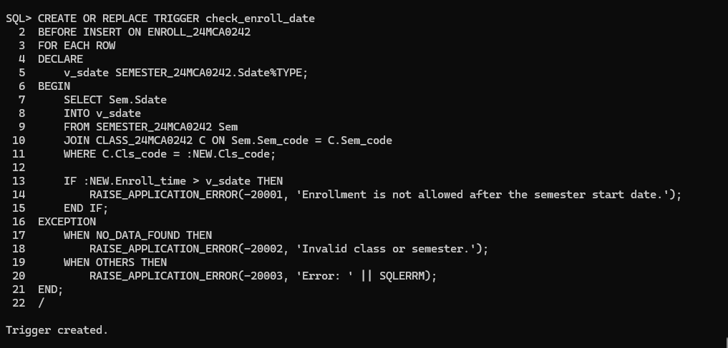

**TESTING THE TRIGGER:**

INSERT INTO ENROLL_24MCA0242 (Cls_code, Reg_no, Enroll_time, Grade)

VALUES ('CLS01', 'R0001', TO_DATE('2023-09-15', 'YYYY-MM-DD'), 'A');

INSERT INTO ENROLL_24MCA0242 (Cls_code, Reg_no, Enroll_time, Grade)

VALUES ('CLS03', 'R0002', TO_DATE('2023-05-15', 'YYYY-MM-DD'), 'A');

**TESTING OUTPUT:**

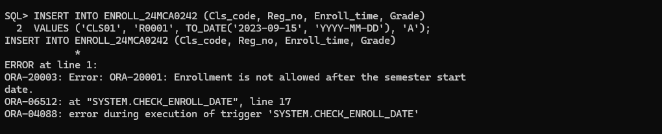

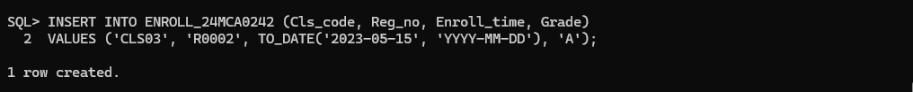

1. Implement and test a trigger to ensure that number of departments in a school cannot exceed three.

**CODE:**

CREATE OR REPLACE TRIGGER check_department_limit

BEFORE INSERT ON DEPARTMENT_24MCA0242

FOR EACH ROW

DECLARE

    v_dept_count NUMBER;

BEGIN

    SELECT COUNT(*)

    INTO v_dept_count

    FROM DEPARTMENT_24MCA0242

    WHERE SCode = :NEW.SCode;

    IF v_dept_count >= 3 THEN

        RAISE_APPLICATION_ERROR(-20003, 'A school cannot have more than 3 departments.');

    END IF;

END;

/

**OUTPUT:**

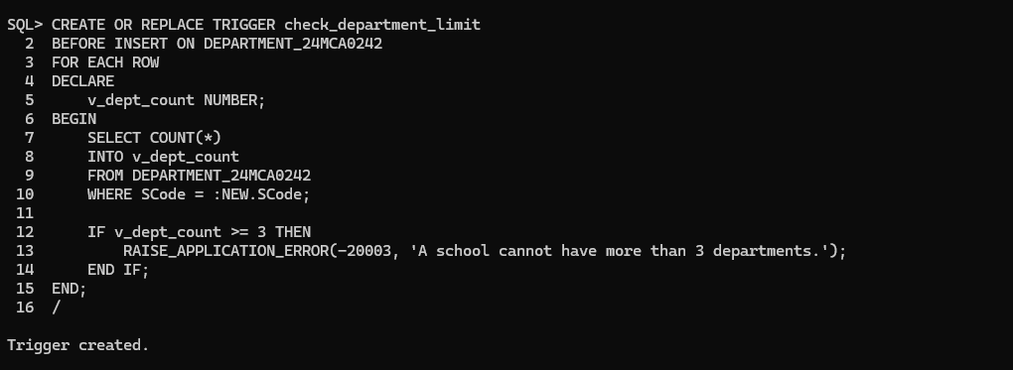

**TESTING THE TRIGGER:**

INSERT INTO DEPARTMENT_24MCA0242 (Dept_id, Dname, SCode, Prof_id)

VALUES ('D0010', 'Dept 4', 'S0006', 'P0004');

**TESTING OUTPUT:**

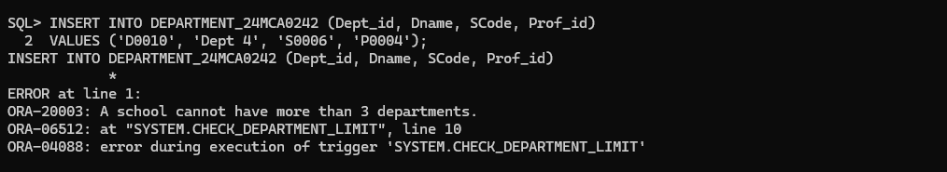

1. Write a trigger to subside referential integrity constraint. (Choose tables of your choice)

**CODE:**

CREATE OR REPLACE TRIGGER trg_professor_delete

BEFORE DELETE ON PROFESSOR_24MCA0242

FOR EACH ROW

DECLARE

v_count NUMBER;

BEGIN

SELECT COUNT(*) INTO v_count

FROM SCHOOL_24MCA0242

WHERE Prof_id = :OLD.Prof_id;

IF v_count > 0 THEN

RAISE_APPLICATION_ERROR(-20001, 'Cannot delete professor: Prof_id is referenced in SCHOOL table.');

END IF;

SELECT COUNT(*) INTO v_count

FROM DEPARTMENT_24MCA0242

WHERE Prof_id = :OLD.Prof_id;

IF v_count > 0 THEN

RAISE_APPLICATION_ERROR(-20002, 'Cannot delete professor: Prof_id is referenced in DEPARTMENT table.');

END IF;

SELECT COUNT(*) INTO v_count

FROM CLASS_24MCA0242

WHERE Prof_id = :OLD.Prof_id;

IF v_count > 0 THEN

RAISE_APPLICATION_ERROR(-20003, 'Cannot delete professor: Prof_id is referenced in CLASS table.');

END IF;

SELECT COUNT(*) INTO v_count

FROM STUDENT_24MCA0242

WHERE Prof_id = :OLD.Prof_id;

IF v_count > 0 THEN

RAISE_APPLICATION_ERROR(-20004, 'Cannot delete professor: Prof_id is referenced in STUDENT table.');

END IF;

END;

/

**OUTPUT:**

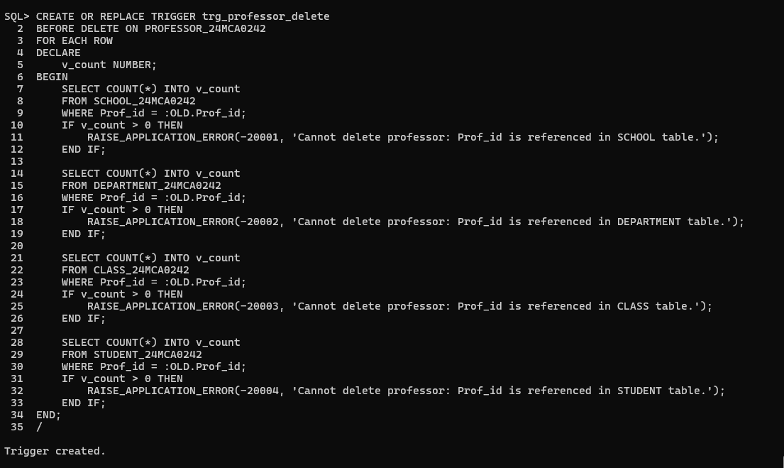

**TESTING THE TRIGGER:**

DELETE FROM PROFESSOR_24MCA0242 WHERE Prof_id = 'P0003';

**TESTING OUTPUT:**

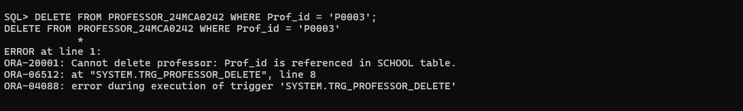

1. Write a PL/SQL program to interchange the department of Professor P0006 and P0007.

**CODE:**

DECLARE

v_dept_id_P0006 PROFESSOR_24MCA0242.Dept_id%TYPE;

v_dept_id_P0007 PROFESSOR_24MCA0242.Dept_id%TYPE;

BEGIN

SELECT Dept_id INTO v_dept_id_P0006

FROM PROFESSOR_24MCA0242

WHERE Prof_id = 'P0006';

SELECT Dept_id INTO v_dept_id_P0007

FROM PROFESSOR_24MCA0242

WHERE Prof_id = 'P0007';

UPDATE PROFESSOR_24MCA0242

SET Dept_id = CASE

WHEN Prof_id = 'P0006' THEN v_dept_id_P0007

WHEN Prof_id = 'P0007' THEN v_dept_id_P0006

END

WHERE Prof_id IN ('P0006', 'P0007');

COMMIT;

DBMS_OUTPUT.PUT_LINE('Departments interchanged successfully between Professors P0006 and P0007.');

EXCEPTION

WHEN NO_DATA_FOUND THEN

DBMS_OUTPUT.PUT_LINE('One or both professors not found.');

WHEN OTHERS THEN

DBMS_OUTPUT.PUT_LINE('Error: ' || SQLERRM);

END;

/

**OUTPUT:**

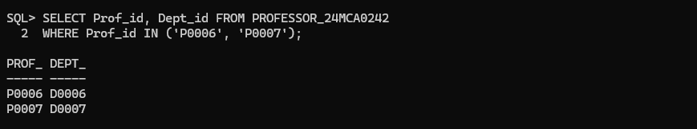

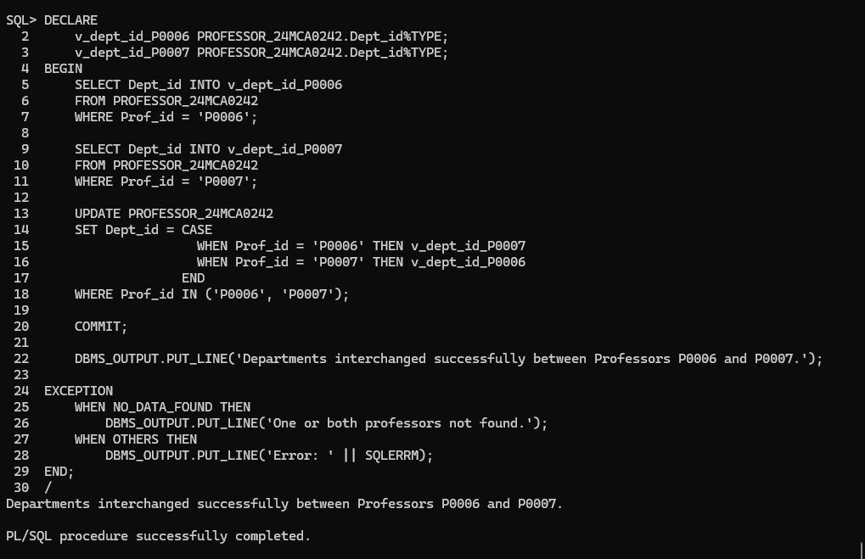

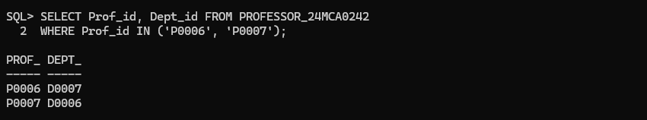

1. Create a function that takes department ID and returns the name of the Head of the department.

**CODE:**

CREATE OR REPLACE FUNCTION get_department_head(p_dept_id IN DEPARTMENT_24MCA0242.Dept_id%TYPE)

RETURN PROFESSOR_24MCA0242.Prof_name%TYPE IS

v_head_name PROFESSOR_24MCA0242.Prof_name%TYPE;

BEGIN

SELECT p.Prof_name

INTO v_head_name

FROM PROFESSOR_24MCA0242 p

JOIN DEPARTMENT_24MCA0242 d ON p.Prof_id = d.Prof_id

WHERE d.Dept_id = p_dept_id;

RETURN v_head_name;

EXCEPTION

WHEN NO_DATA_FOUND THEN

RETURN NULL;

WHEN OTHERS THEN

RETURN 'Error: ' || SQLERRM;

END;

/

**OUTPUT:**

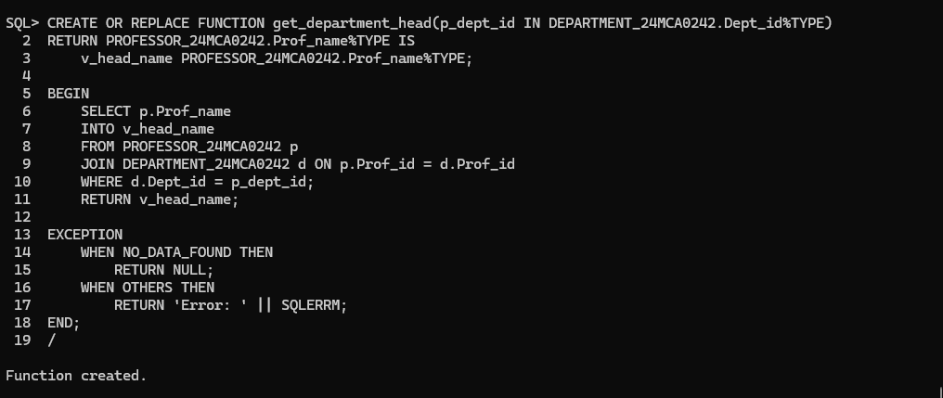

**TESTING THE FUNCTION:**

DECLARE

v_head_name PROFESSOR_24MCA0242.Prof_name%TYPE;

BEGIN

v_head_name := get_department_head('D0003');

IF v_head_name IS NOT NULL THEN

DBMS_OUTPUT.PUT_LINE('Head of Department D0003: ' || v_head_name);

ELSE

DBMS_OUTPUT.PUT_LINE('No head found for Department D0003.');

END IF;

END;

/

**TESTING OUTPUT:**

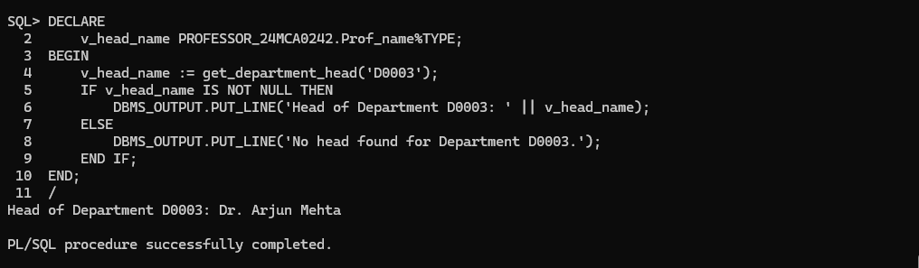

1. Create a function that displays the age of the student from his DOB.

**CODE:**

CREATE OR REPLACE FUNCTION get_student_age(p_reg_no IN STUDENT_24MCA0242.Reg_no%TYPE)

RETURN NUMBER IS

v_age NUMBER;

BEGIN

SELECT TRUNC(MONTHS_BETWEEN(SYSDATE, DoB) / 12)

INTO v_age

FROM STUDENT_24MCA0242

WHERE Reg_no = p_reg_no;

RETURN v_age;

EXCEPTION

WHEN NO_DATA_FOUND THEN

RETURN NULL;

WHEN OTHERS THEN

RETURN -1;

END;

/

**OUTPUT:**

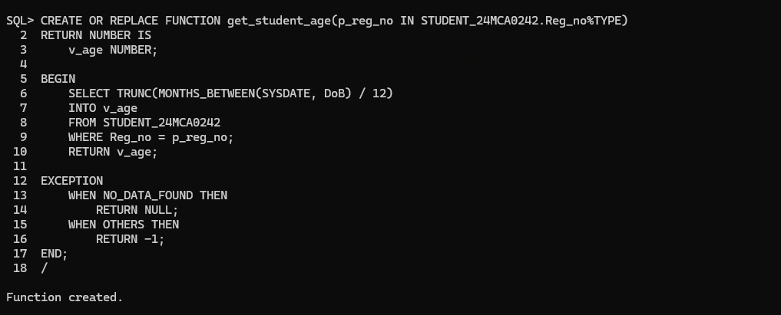

**TESTING THE FUNCTION:**

DECLARE

v_age NUMBER;

BEGIN

v_age := get_student_age('R0001');

IF v_age IS NOT NULL AND v_age >= 0 THEN

DBMS_OUTPUT.PUT_LINE('Age of Student R0001: ' || v_age || ' years');

ELSIF v_age IS NULL THEN

DBMS_OUTPUT.PUT_LINE('No student found with Reg_no R0001');

ELSE

DBMS_OUTPUT.PUT_LINE('Error calculating age');

END IF;

END;

/

**TESTING OUTPUT:**

